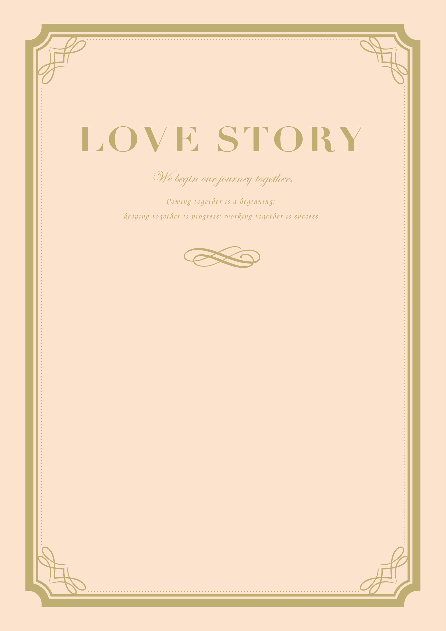

**2020,04,18**

*We said “I DO!”*

*He stole her heart*

**2020,07,23**

*She stole his last name*

**2020,04,18**

2020,04,18

*First met*

**Taro & Hanako**